**CSV Report**



**Lighthouse Testing Reports**

This document presents the Lighthouse testing report 1, which was conducted immediately after the website's completion. Additionally, attached are the images for Lighthouse Report 2, reflecting the results after improvements were made. I have also included the complete expanded report files for both the initial and final reports in the relevant GitHub repository.

**Lighthouse Testing Report 1:**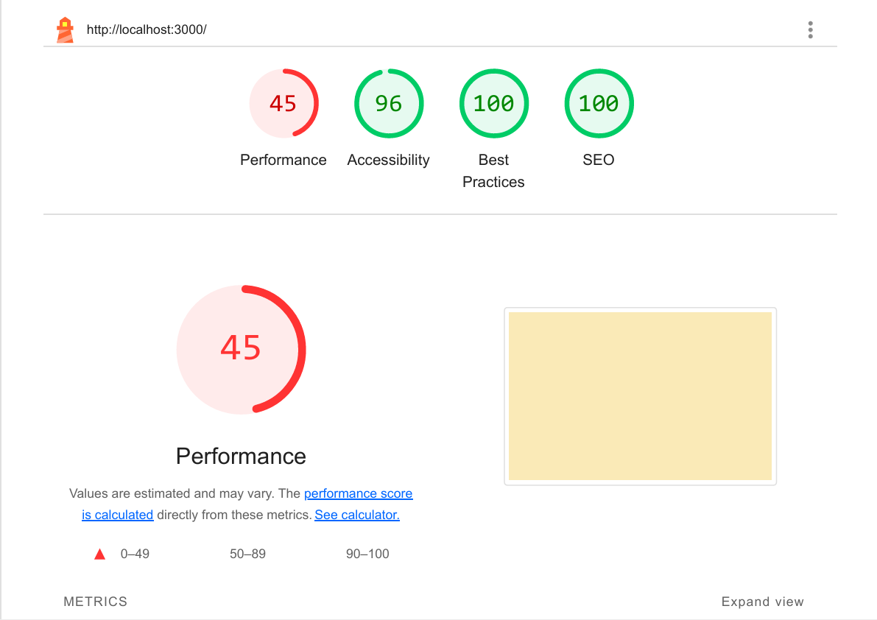

**Lighthouse Testing Report 2:**

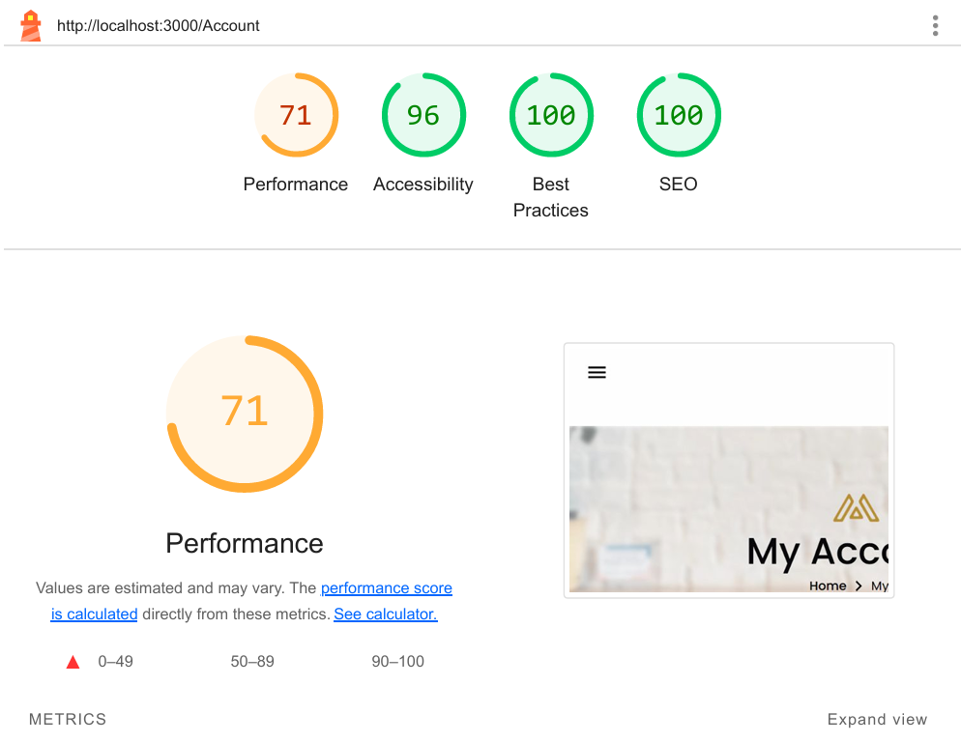

**Error Handling Report**

* **Responsiveness:**

I faced the issue while making my website responsive. Due to this, my Lighthouse Performance report was 45% and after when I tackled with the issue, it improved by 71%.

* **Adjusting Images:**

I faced the issue of making my images fix any screen size but I failed. After a lot of research work and learning, I finally found out the solution to this problem and at last fixed the images according the screen size.

* **Menu Bar:**

I faced the issue of making my menu bar visible only on smaller screen sizes. Finally after research and efforts, I made it to make my menu bar being displayed only on smaller screen sizes.

This report is made after the results have been taken out from the required sources (Lighthouse and CSV Reports). Further, Error Handling Report is made to highlight the problems faced and the solutions made.